|  |
| --- |
| Close-up image showing the leaf-sides of two oversized books side-by-side on a bookshelf, with additional books in soft focus background |
| Assignment 4 |
| |  |  |  | | --- | --- | --- | | Rushabh Barbhaya | 3/14/19 | SYS 660 – Decision and Risk Analysis | |

Table of Contents

Too Long; Didn’t Read 2

Question 1 3

Solution 1 3

***Assumptions:*** 3

***Modeling:*** 3

***Results:*** 4

Question 2 5

Solution 2 5

***Assumptions:*** 5

***Modeling*** 5

***Results*** 6

Question 3 11

Solution 3 11

***Case 1 – Buying the equipment*** 11

***Case 2 – Leasing*** 13

Question 4 16

Solution 4 16

***Solution for Question 4(a)*** 16

***Solution for Question 4(b)*** 16

References 18

List of Figures 19

All the references are indicated is IEEE style and mentioned at the end.

# Too Long; Didn’t Read

Solutions 1

≈ 1.75 Boeing 747-8 planes

Solution 2

≈ 12,500 miles

Solution 3

Go for leasing the computer system. No change observed

Solution 4

1. The breakeven point is between year 20 & 21
2. The cost of dam exceeds the benefits at the end of the year 71.

# Question 1

How many pounds of toothpaste are used in the US each day? You would need to transfer all of this toothpaste to a certain location via 747 aircrafts. How many 747 aircrafts would it take to move it.

Your assumptions and calculations should be very clear to comprehend. If you are using any data from external sources do NOT forget to mention your source. What is your lower bound, upper bound and best guess for your estimates.

# Solution 1

## ***Assumptions:***

An average American uses 0.0283 ounces of toothpaste a day[1], which is about 0.8g. These statistics are per use based. Therefore, I assumed that the range of use would be around 0.02 oz to 0.03 oz per use. An average person uses the toothpaste for a maximum of 2 times. I also assumed the worst that for that day the toothpaste wasn’t used.

I tried to approach this model using simulation techniques along with Monte Carlo. I used 2 random number generators. First, I used a triangular distribution keeping its mode at 0.0283 but keeping its minimum at 0.02 and maximum at 0.03 as mentioned earlier. For the second one, I again used a triangular distribution with a minimum at 0, mode at 1 and maximum at 2. I used *python* for solving this problem.

The population of US (as of March 14, 2019) is 328,392,623[2] . The population keeps on varying at regular intervals. But I choose the value which was available at the time of this modeling for this assignment.

For the cargo space of 747 (Assuming Boeing 747), I looked up the values that can help. There are many variants of Boeing 747 planes. I chose Boeing 747-8 which has a cargo hold of 154 tons[3]. 154 US tons is equivalent to 308,000 pounds. I choose to ignore the packaging element for the toothpaste.

## ***Modeling:***

For modeling, as mentioned earlier I used 2 triangular distribution generators. Then I generated data for the population of US, i.e. all 328,392,623 people. Since it was really time consuming to calculate for every person, I generated a sample set and then later multiplied by the difference. For this to be as precise as possible I ran a short Monte Carlo operation on it. I ran it 10 times and took the average of it.

Once I had the total toothpaste consumption, I calculated the number of planes required for carrying the cargo.

Once I had all the observations and calculations, I ran another Monte Carlo series to be perfectly sure of all the possible scenarios. I ran the simulation for just 10 iterations as it involved a lot of calculations and the outputs took a lot of time. I believe my code needs to be optimized to get the results faster.

I also calculated 95% confidence intervals to compensate for the fewer iterations.

## ***Results:***

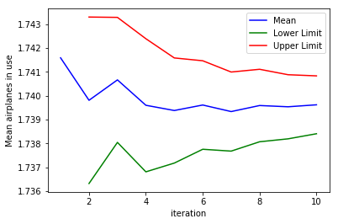

Figure : Number of airplanes used

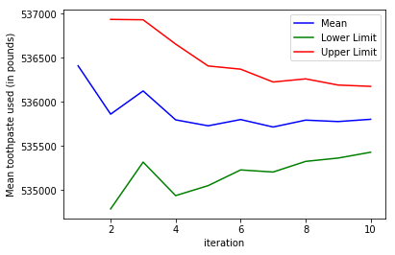

Figure : Average toothpaste used

As is the case after running Monte Carlo the mean started to converge to a point. The average number of toothpastes used a day came to 535,802.888 pounds and the number of Boeing 747-8 required to carry out this cargo was 1.74

The result is shown in Figure 3 & Figure 4 respectively

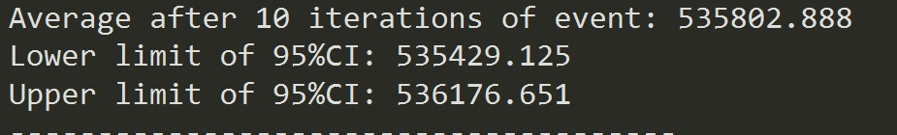

Figure : Average toothpaste used per day

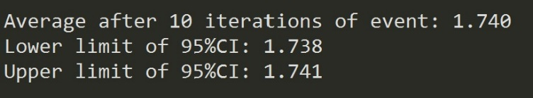

Figure : Average number of airplanes needed to carry the cargo

# Question 2

You are trying to quantitatively estimate the impact of Stevens’ commuters on roadway congestion in order to determine alternative bus routes to reduce the number of drivers. To do so, you will estimate the total number of miles traveled by people driving to campus on an average weekday, including all faculty, staff and students. Estimate the total number of miles driven and report a range of values. You must source all the documents and/or websites you use to find data.

# Solution 2

## ***Assumptions:***

Before solving this problem, we need to make some boundaries for this model. First, the things which must be taken at given value. The population of Stevens Institute of Technology. The breakup of entire Stevens Fraternity can be checked on the website as indicated by the reference point[4]

The breakup of students, faculty and staff on Stevens website was last updated for Fall semester of 2018. It is necessary for students of freshman year to stay in Stevens Housing therefore their travel time will be next to nothing. But I’m still considering Stevens Leasing distance as a bus/car/bike distance. Students who are in sophomore year or ahead are free to choose a housing of their choice. Therefore some traveling is involved. But still these students prefer to stay near Hoboken (I work at the Post Office of Stevens Institute therefore I know about this situation.).

Students of Graduate level mostly stay in Jersey City or Union City in New Jersey. Hence, they are some distance away from college but not that far out.

Staff members from the limited survey I conducted are mostly in Union City or Jersey City but a little far out in comparison with Graduate Students. Some do stay close to college but majority of them are in the aforementioned places.

Faculty is mostly housed in 3 places. Hoboken, Jersey City and in the State of New York. I considered the central location from each place for getting an approximate for each distance. Mostly in the 6-10 mile radius.

These are the boundaries for this model. I used a uniform distribution to space everything as uniformly as possible. I ran a Monte Carlo simulation for 100 trials. Initially I divided the groups and later on merged them to get an overall approximate distance traveled.

## ***Modeling***

The model is divided in 4 parts. One for each kind of level, they are Undergraduate students, Graduate Students, Faculties and Staff members. Keeping the condition mentioned above I modeled the students for undergrad to be in Hoboken. Between the range of 0.2 to 0.8 miles away. For graduate level students they are mostly in the radius of 1 to 3 miles from college. Staff is 3 to 7 miles away. Lastly, faculty was divided in 3 groups. First, going 1 to 2 miles away. Second, between 3 to 5 miles away and Third, between 6-10 miles away.

A random uniform variable generator was used for all these cases to space everyone as evenly as possible. The distances were collected for each member and were added together. Each section total was also recorded in a separate bin.

## ***Results***

For undergraduate students the average distance, after 100 trails, was around 1,716 miles. The graph as details the 95% confidence intervals for each trial. Figure below shows it.

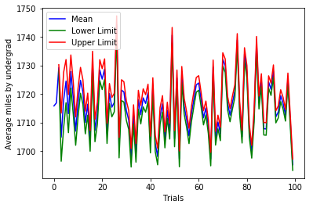

Figure : Undergraduate students’ graph for 100 trials

The following figure shows the statistics after these 100 trails

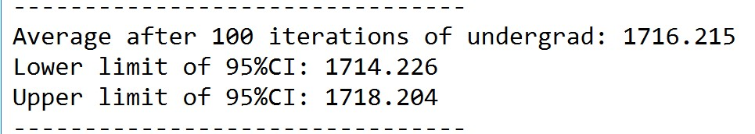

Figure : Statistics for Undergraduate students

Similarly, each section has its own graph and statistics combination. Please refer the figures below for them

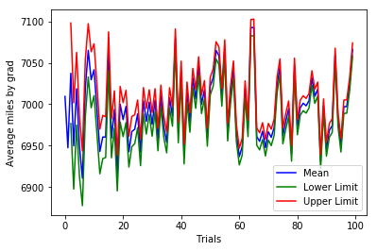

Figure : Graduate student’s graph of 100 trials

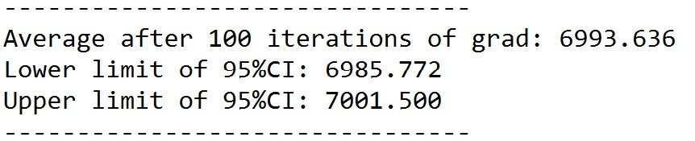

Figure : Statistics for graduate students

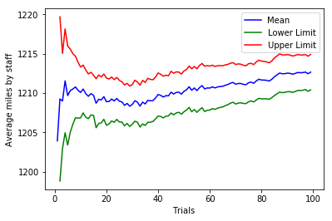

Figure : Staff's distance after 100 trials

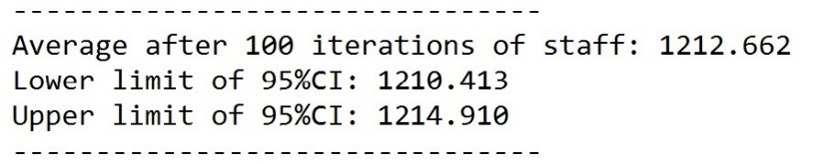

Figure : Statistics for staff's distance

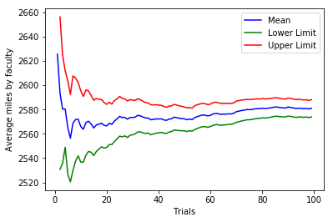

Figure : Average distance travelled by faculty after 100 trials

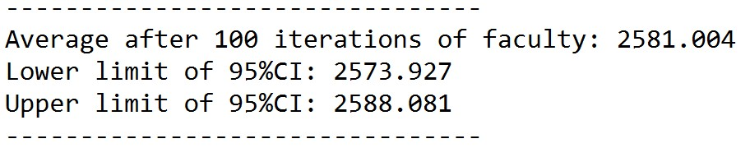

Figure : Statistics for faculties distance

Now that we have detailed view of each graph let’s just check the whole picture. The distance travelled by everyone to Stevens Institute of Technology can be seen from the figure below.

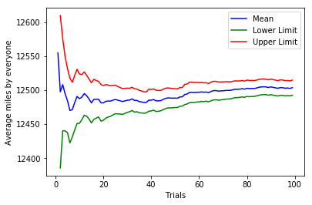

Figure : Average distance traveled by everyone

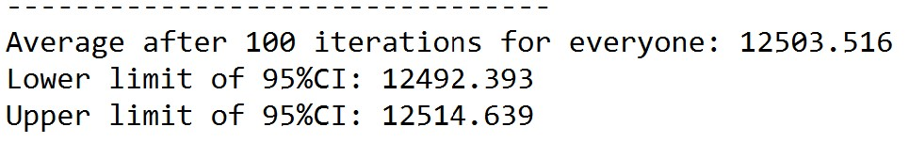

Figure : Statistics for everyone

The average distance travelled is about 12,500 miles with a 95% confidence of the average distance travelled being between 12,492.393 miles and 12,514.639 miles.

# Question 3

Your company is considering the acquisition of a computer system for $22,000 for a five-year project. You may either buy the computer with borrowed money at 8%, with a single repayment at the end of 5 years, or lease it with yearly payments of $7500, $6500, $5500, $4500, and $3500 at the end of years 1 through 5. The salvage value is $2000, and the expected yearly benefits are $6000. Your corporate income tax rate is 50%, depreciation is by double declining balance, and discount rate is 8%.

a) Should you buy or lease?

b) Does your answer change if your discount rate is 5%? What if it is 15%?

# Solution 3

## ***Case 1 – Buying the equipment***

Considering the first case where the company is considering buying the computer system. There are a lot of parts involved in this problem. But first let’s check the double declining method of depreciation calculation. In double declining method, the interest rate is calculated in terms of product life. In our case it’s 5 years. In these 5 years, the product should depreciate 20% year over year on the book value. For double declining method it will depreciate twice as fast, i.e. 40% YoY.[5]

The depreciated amount calculation is shown below. These calculations are based on what we thought in our class of EM600. I referred to the class notes I have from that class.

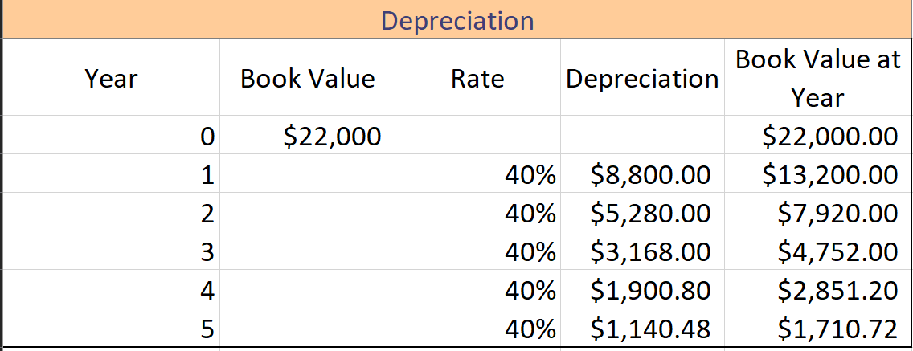

Figure : Depreciation Calculation for Case 1

Depreciation is calculated as Rate * Book value at that year. &

Book value for that year becomes previous years Book Value – Depreciation Value.

For Tax calculation at year 5. We look at the salvage value and the book value at that year’s end. Since the tax rate is 50% the tax amount comes to $144.64 which needs to be paid when selling the system.

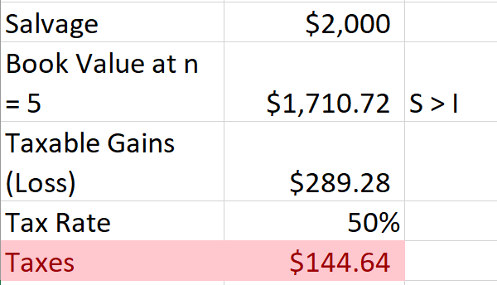

Figure : Taxable Gains calculation in Case 1

Now, I calculated the loan repayment amount which comes to $32,352.22

Now that I have all the possible variables I would need, I Tabulated the Income Statement and calculated the Cash Flow statement for this case. The Income Statement can be viewed below.

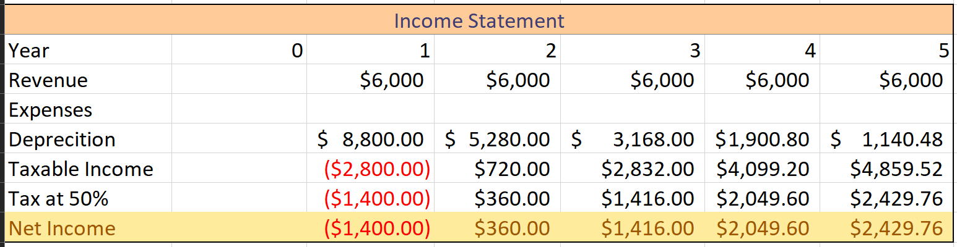

Figure : Income Statement for Case 1

And here’s the Cash Flow Statement

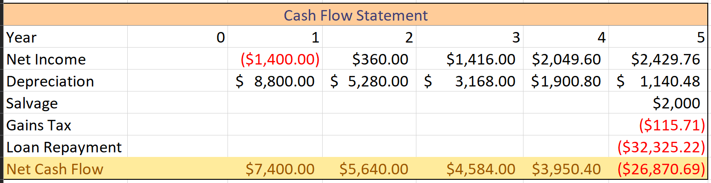

Figure : Cash Flow Statement for Case 1

Now, I have all the calculations in, but there is one small step. All the values need to convert to present values and we need the Net Present Value at the end. The Calculation of which is shown in the figure below.

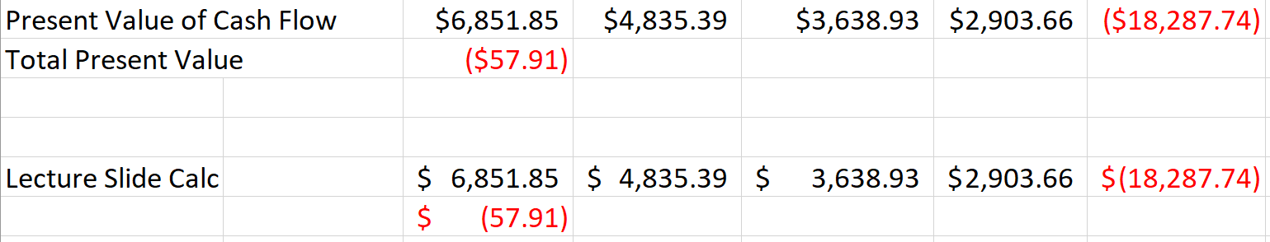

Figure : Present Value Calculation for Case 1

Here’s a graph to show all the cash flows in this case. To summarize, because we have to payback the loan amount at the end of 5 years the cash flow at the end of the term takes a sudden dip and we end up losing monetary value at the end. Not a lot though, about (-$58) at the end.

I would recommend looking for some better financing options for this.case.

Figure : Cash Flow diagram for Case 1

## ***Case 2 – Leasing***

In this case we are leasing the computer system for 5 years with a gradually decreasing amount of lease payments. For this case I had to look up if we can involve depreciation in the calculations.[6]

It turns out that we can involve the depreciation in the calculations. One more thing I learnt is, we have to subtract the salvage value form the cost of the leased equipment. In our case the cost of leased equipment is $22,000 and the salvage value is $2,000. Therefore, depreciation is calculated on $20,000. The calculation is shown in the figure below.

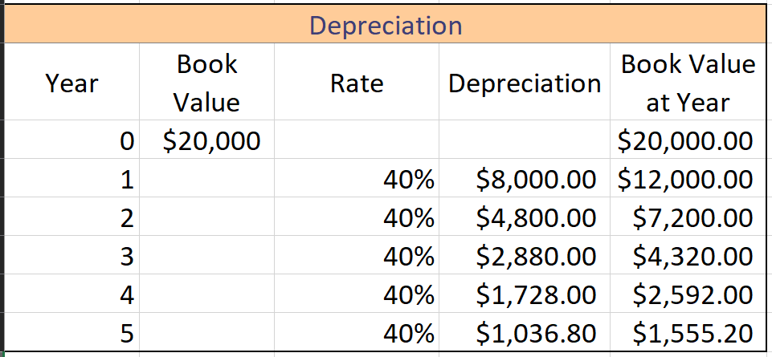

Figure : Depreciation calculation for Case 2

In the limited time I researched about tax gains when selling the computer system. I couldn’t find if tax gains are applicable on it. So, for this case I didn’t calculate the tax gains, but the result won’t have any impact.

So, now that we have the depreciation value. Next step is to calculate the income statement. The figure below shows the tabular format for income statement.

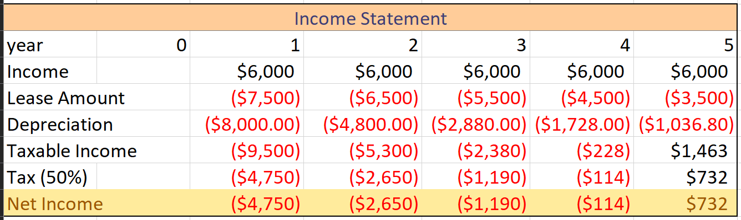

Figure : Income Statement for Case 2

Now, I generated the Cash Flow Statement from the income statement above. The figure below shows the tabular format for Cash Flow Statement

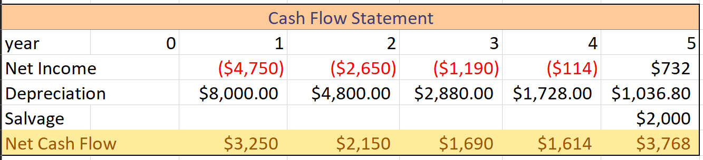

Figure : Cash Flow Statement for Case 2

Now that we have all the values for the calculation, we can calculate the net present value. The figure below shows that calculation

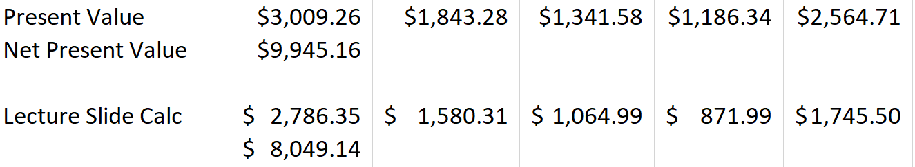

Figure : Net Present Value Calculation for Case 2

At the end, we have about $8,000 surplus in our hands. If we had accounted for tax gains on salvage value the net present value would have been a little short of $8,000. Please refer the figure below for Cash Flow Graph.

Figure : Net Cash Flow Diagram for Case 2

For solution to Question 3(a), let’s look at the net present values from both the cases. In case 1 (Buying the computer system) we are somehow losing value as compared to case 2 (Lease the computer system).

The following table shows the impact of different discount rates.

|  |  |  |  |
| --- | --- | --- | --- |
| Rates | Case 1 Net Present Value | Case 2 Net Present Value | |
| Excel | Lecture |
| 8% | - $ 57.91 | $ 9,945.16 | $ 8,049.14 |
| 5% | - $ 1,703.45 | $ 10.785.72 | $ 9,383.65 |
| 15% | $ 2,598.28 | $ 8,359.37 | $ 5,876.48 |

My answer doesn’t change. I expected it to change for 15% discount rate. But for some reason it didn’t change.

# Question 4

A benefit-cost study of a proposed dam is conducted. The dam costs $75 million to construct. The study estimates a stream of social benefits of $9.5 million per year (from avoided flood damage, hydroelectric power, etc.) and annual costs of $4 million ($2 million from operation and $2 million in environmental damages). Note: Feel free to use Excel/etc. on this problem.

a) Assuming a social marginal rate of time preference (i.e. social discount rate) of 4% per year, how many years does it take for the dam to “break even” (i.e., the NPV of benefits just exceed the NPV of costs)?

b) Opponents of the study disagree with using a single discount rate of 4% for all of the benefits and costs. They argue that the $2 million in environmental costs should only be discounted at 1%. Develop a graph of the NPV as a function of the years of operation – from 0 to 300 years – for this group of opponents. Assume all benefits and costs are $0 after the end of operation of the dam. In which year would the opponents be in favor of closing the dam facility, and why?

# Solution 4

## ***Solution for Question 4(a)***

The cost of the dam is a one-time cost and the O & M (Operation and Maintenance) costs are 4 million each year. The annual benefits are 9.5 million.

So, when I plug in the formulas for Net Present Value, we start to benefits outweigh the cost at year 21. The figure below shows the exact point where benefits gets higher than the costs.

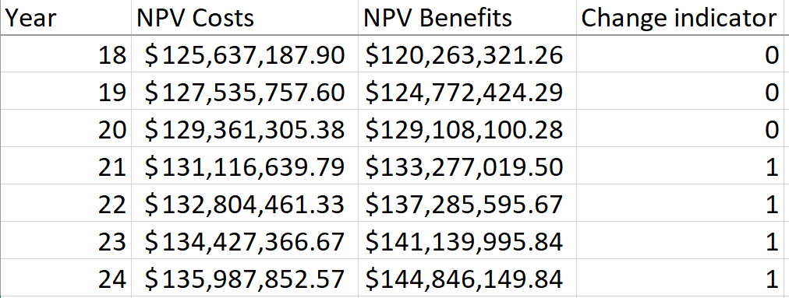

Figure : Breakeven point

It would be more accurate to say that the breakeven point is 20.1031 years or 7,337.6 days

## ***Solution for Question 4(b)***

I didn’t understand what end of operation means. Since, the dam is built it should continue to operate and provide its uses. So, my best guess was to remove the principle amount for dam to be paid completely after it starts to show profit. I kept on assuming 4% rate for other factors.

Figure : Graph of Cost Calculation and Benefits calculation

Here we can see that the graph shows that the turnover point when we consider discounting factor for environmental costs to be 1% is between year 26 and 27. But later, between year 70 and 71 the costs grows larger than the benefits. It is represented in the graph above.

Since the cost keeps on growing, therefore the operations at the dam should be concluded by the end of year 70.

End

# References

|  |  |
| --- | --- |
| [1] | Katie, "The Organized Pack Rat," Blogger, 18 May 2011. [Online]. Available: http://theorganizedpackrat.blogspot.com/2011/05/toothpaste-math.html. [Accessed 14 March 2019]. |
| [2] | "worldometers," 14 March 2019. [Online]. Available: http://www.worldometers.info/world-population/us-population/. [Accessed 14 March 2019]. |
| [3] | "Deagel.com," 27 October 2016. [Online]. Available: http://www.deagel.com/Airliners/Boeing-747-8F_a000202006.aspx. [Accessed 14 March 2019]. |
| [4] | S. I. o. Technology, "Stevens Institute of Technology Facts and Statistics," August 2018. [Online]. Available: https://www.stevens.edu/about-stevens/facts-statistics. [Accessed 16 March 2019]. |
| [5] | H. Averkamp, "Accounting Coach," 13 January 2019. [Online]. Available: https://www.accountingcoach.com/blog/double-declining-balance-method-of-depreciation. [Accessed 15 March 2019]. |
| [6] | C. Carter, "bizfluent," 26 September 2017. [Online]. Available: https://bizfluent.com/how-12075758-calculate-depreciation-leased-equipment.html. [Accessed 15 March 2019]. |

# List of Figures

Figure 1: Number of airplanes used 4

Figure 2: Average toothpaste used 4

Figure 3: Average toothpaste used per day 4

Figure 4: Average number of airplanes needed to carry the cargo 4

Figure 5: Undergraduate students’ graph for 100 trials 6

Figure 6: Statistics for Undergraduate students 6

Figure 7: Graduate student’s graph of 100 trials 7

Figure 8: Statistics for graduate students 7

Figure 9: Staff's distance after 100 trials 8

Figure 10: Statistics for staff's distance 8

Figure 11: Average distance travelled by faculty after 100 trials 9

Figure 12: Statistics for faculties distance 9

Figure 13: Average distance traveled by everyone 10

Figure 14: Statistics for everyone 10

Figure 15: Depreciation Calculation for Case 1 11

Figure 16: Taxable Gains calculation in Case 1 12

Figure 17: Income Statement for Case 1 12

Figure 18: Cash Flow Statement for Case 1 12

Figure 19: Present Value Calculation for Case 1 13

Figure 20: Cash Flow diagram for Case 1 13

Figure 21: Depreciation calculation for Case 2 14

Figure 22: Income Statement for Case 2 14

Figure 23: Cash Flow Statement for Case 2 14

Figure 24: Net Present Value Calculation for Case 2 15

Figure 25: Net Cash Flow Diagram for Case 2 15

Figure 26: Breakeven point 16

Figure 27: Graph of Cost Calculation and Benefits calculation 17